

**Object Oriented Programming**

**Assignment # 4**

**Name:** Muhammad Suhaib Salman

**Roll#:** 200768

**Class:** BEEE-3A

**Source Code**

#include <iostream>

using namespace std;

class QuizGen

{

public:

virtual void q_gen() {}

virtual void pose_q() {}

virtual int calculate() {}

virtual int total_marks() {}

};

class OneWord: public QuizGen

{

string question,correct_ans,student_answer;

public:

void q_gen()

{

cout<<"\n\nPlease enter question:";

getline(cin,question);

cout<<"\n\nPlease provide the correct answer: ";

getline(cin,correct_ans);

}

void pose_q()

{

cout<<"\n\n#####################"<<endl;

cout<<"\n\n"<<question<<endl;

getline(cin,student_answer);

}

int total_marks()

{

int tot_marks=5;

return tot_marks;

}

int calculate()

{

int marks=0;

if (student_answer==correct_ans)

{

marks=5;

return marks;

}

else

{

marks=0;

return marks;

}

}

};

class MCQs : public QuizGen

{

string question,correct_ans,student_ans,option_1,option_2,option_3;

public:

void q_gen()

{

cout<<"\n\nMCQ: "<<endl;

cout<<"\nPleas enter the question: ";

getline(cin,question);

cout<<"\nPlease provide 3 options: ";

cout<<"\nOption # 1: ";

getline(cin,option_1);

cout<<"\nOption # 2: ";

getline(cin,option_2);

cout<<"\nOption # 3: ";

getline(cin,option_3);

cout<<"\nPlease provide the correct option as '1','2' or '3': ";

getline(cin,correct_ans);

}

void pose_q()

{

cout<<"\n\n################"<<endl;

cout<<"\nSelect the option as '1' , '2' or '3' \n\n";

cout<<"\n\n"<<question<<endl;

cout<<"\n1: "<<option_1<<endl;

cout<<"\n2: "<<option_2<<endl;

cout<<"\n3: "<<option_3<<endl;

getline(cin,student_ans);

}

int total_marks()

{

int tot_marks=1;

return tot_marks;

}

int calculate()

{

int marks=0;

if (student_ans==correct_ans)

{

marks=1;

return marks;

}

else

{

marks=0;

return marks;

}

}

};

int main()

{

QuizGen **ptr2;

int size=0;

cout<<"\nHow many questions do you want to create: ";

cin>>size;

ptr2 = new QuizGen *[size];

for (int i=0;i<size;i++)

{

cout<<"\n\nWhat type of question do you want? ";

cout<<"\nPress '1' for One word and '2' for MCQ "<<endl;

int x=0;

cin>>x;

cin.ignore();

if (x==1)

{

ptr2[i] = new OneWord;

}

if (x==2)

{

ptr2[i]= new MCQs;

}

ptr2[i]->q_gen();

}

cout<<"\n\n\n\t##############Quiz############\n\n\n";

for (int i=0;i<size;i++)

{

ptr2[i]->pose_q();

}

cout<<"\n\n\n";

int result=0,tm=0;

for (int i=0;i<size;i++)

{

tm = tm+ptr2[i]->total_marks();

}

for (int i=0;i<size;i++)

{

result=result+ptr2[i]->calculate();

}

cout<<"\nTotal marks: "<<tm<<endl;

cout<<"\nThe total marks obtained by the student: "<<result<<endl;

float perc = (result*100)/tm;

cout<<"\nPercentage: "<<perc<<"%\n"<<endl;

if (perc<40)

{

cout<<"Status: FAILED\n\n"<<endl;

}

else

{

cout<<"Status: PASSED\n\n"<<endl;

}

}

**OUTPUT**

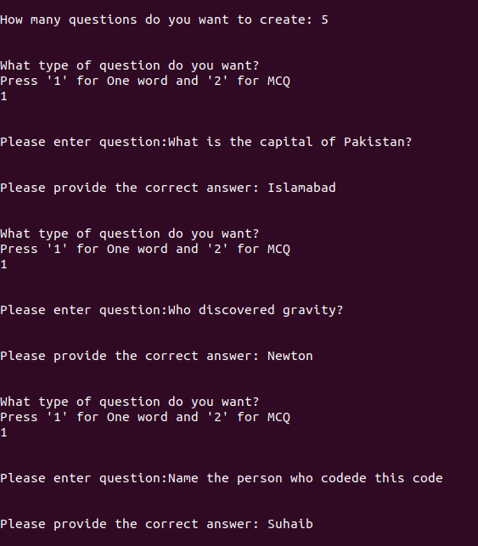

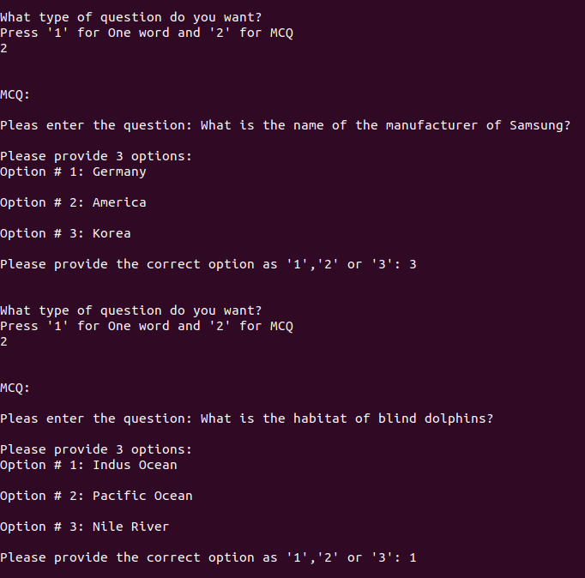

**Quiz**

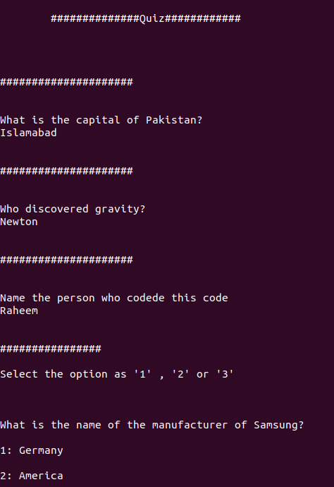

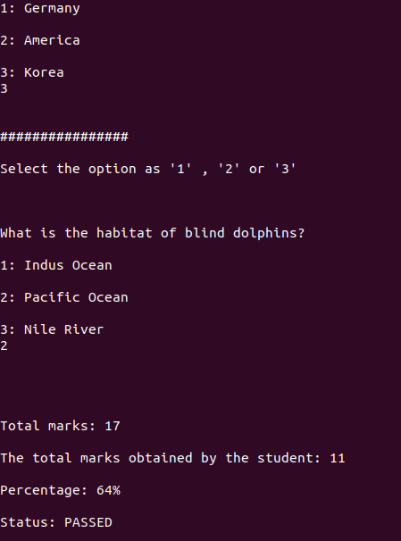

**Working:**

* Firstly I created a base class called QuizGen and then I created two classes called MCQs and OneWord that were derived from QuizGen.
* After constructing the basic structure I created four virtual functions in QuizGen class.

**OneWord:**

* Then in OneWord class I defined the four functions.
* q_gen() function asks the teacher the question and then in the end it asks the teacher for the correct answer.
* pose_gen() function then poses the question to the student and then asks the student for answer.
* The calculate() function runs after the running of q_gen() and pose_gen().
* The calculate() function compares the teacher’s answer and student’s answer and then it rewards marks accordingly.
* The total_marks( ) function calculates the total marks with each teacher’s question.

**MCQs:**

* This class works like the OneWord class and it also has four functions
* Except in this class it asks the teacher for the four options in addtition to the question in q_gen() class and in the end it also asks for correct option as ‘1’ , ‘2’ or ‘3’.
* pose_gen() function poses the question and the four options to the student (that were provided in q_gen() function) and then in the end it asks the student for option.
* After that the calculate() function compares the values like in the OneWord class and then total_marks() function also works like it worked in the OneWord class.

**Int main():**

* In int main() I created a double pointer so that the program would be able to create an array of dynamic size.
* After that I created an array of pointer of QuizGen() type and assigned it to the double pointer.
* After that I created a for loop to run q_gen() function for each element in the array.
* Similarly I created for loops for all functions for each element in the array.
* In the end it will display the obtained marks with the help of calculate() function.
* It will also display the total marks with help of total_marks() function.
* The program would also be able to display the percentage with the help of calculate() and total_marks() function.